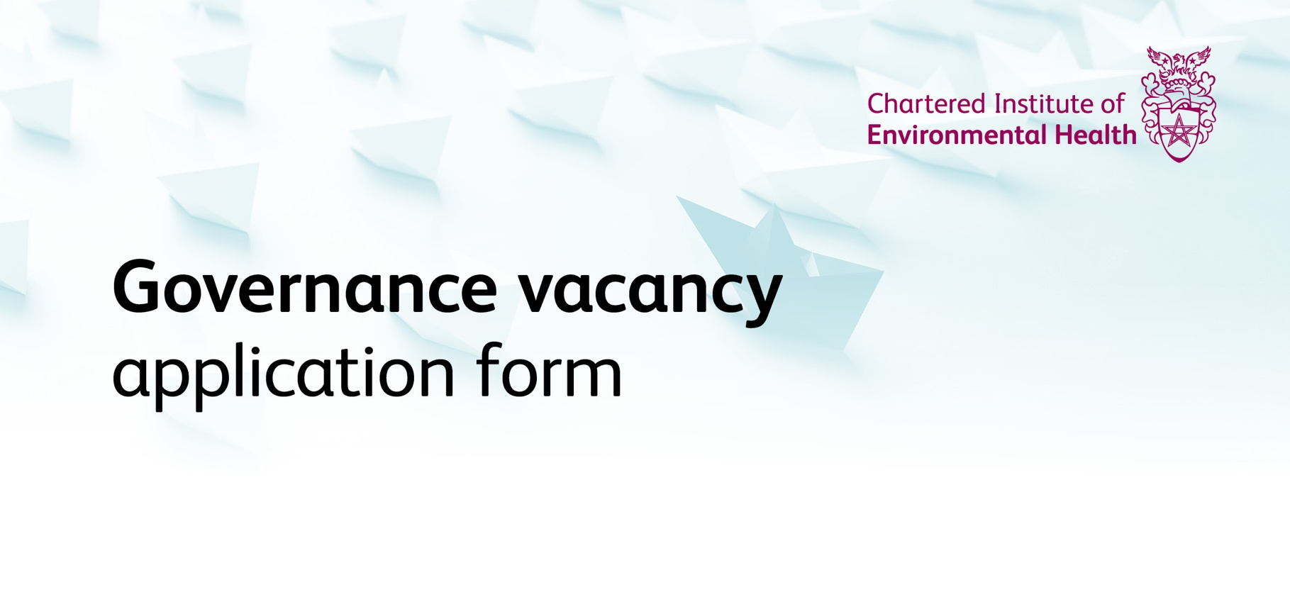

Instructions

- Before completing this form, please read the candidate information pack carefully.

- We use a blind-application process. This means that, prior to interview, the shortlisting panel will not see any of your personal data. We do this to help ensure that our governance recruitment process is as fair as possible. For the same reason, we use an application form rather than CVs.

- The form contains five mandatory sections. Please ensure that you complete each section in full and provide all requested information.

- Section 6 provides us with equality and diversity data. Completion is optional, although we would appreciate your help by completing it. None of the information in this section will be seen by the panel, except in aggregate (after the recruitment round is complete) for monitoring purposes.

- Please adhere to the stated word count; content beyond it will be removed before shortlisting.

- Please provide contact details that you use and check regularly.

- Please send the completed form as a Word document. Sections 1, 2 and 5 will be removed before short-listing and, as a result, any applications which are not editable will not be considered further.

- Applications must be submitted by email to c.kanu@cieh.org and must arrive by 09.00, on Friday 9 October 2020.

- Only applications which are submitted using this form will be accepted.
Section 1: Personal details

Please complete all fields
Title: | Surname: |  | Forename:
Which role are you applying for? Note that you must submit a separate form for each role.

If you are a current CIEH member, include your membership number here:

Address:

Phone: |  | Email:
Country of residence:

Section 2: Career history

Please use this section to provide a brief summary of paid employment or volunteer/non-executive roles that you have held. This section will not be seen by the panel at the shortlisting stage, so you should not cross reference to this from other parts of the form.
Dates from/to | Job title and employer/organisation name | Key responsibilities

Section 3: Competencies

This section asks you to provide examples which demonstrate how you meet the necessary competencies and how your experience will help you in the role for which you are applying.
Please fill in each field below for competencies 1 to 5 and refer to the candidate pack for examples of evidence that might be relevant. Please complete each field with 350 words or fewer.
- Please give an example which shows you have the skills and experience to contribute to CIEH’s strategic direction.

- Please give an example that demonstrates your understanding of equality and diversity issues.

- Please provide an example that best demonstrates your ability to listen and communicate with a range of stakeholders.

- Please give an example of how you have demonstrated your ability to work effectively as part of a team.

- Please give an example that demonstrates that you have the capacity and skill to understand the needs of our stakeholders.

Section 4: Experience

Please give details of any other recent relevant experience that will help us assess your suitability for this role. This experience may be obtained, for example, through your employment, voluntary or charity work.
If there are any desirable criteria/backgrounds listed for the role for which you are applying, please address them in this section.
Please use no more than 400 words.

Section 5: Declaration

By submitting this application, I certify and declare that:

- All of the information in this application is honest and accurate, to the best of my knowledge and belief
- I do not know of any conflict or potential conflict of interest, which would be relevant to my appointment as a member of one of CIEH’s governance bodies (if not applicable, delete and provide details in the box below)
- I have reviewed the grounds on which I may be disqualified from appointment, set out in the candidate information pack. None of these apply to me (if not applicable, delete and provide details in the box below)
- I am aware of the information set out in the candidate pack provided, in particular the interview date and date for mandatory induction
- I understand that, if appointed, I will be required to make formal, signed declarations that address points (i) to (iii)
Additional information in respect of (ii) and (iii) above, if required.

Section 6: Equality and diversity data

CIEH aims to treat all applications fairly and in accordance with the provisions of the Equality Act 2010.

Completing this form will help us build an accurate picture of the make-up of applicants for governance roles, in encouraging equality and diversity.

Filling in this form is voluntary; it does not form part of your application. If you wish to complete it, please do. It will be removed before your application is considered by the panel.

Gender Man Woman Intersex Non-binary Prefer not to say
If you prefer to use your own term, please specify here …………………………………….…………….

Are you married or in a civil partnership? Yes No Prefer not to say

Age 16-24 25-29 30-34 35-39 40-44 45-49
50-54 55-59 60-64 65+ Prefer not to say

What is your ethnicity?
Ethnic origin is not about nationality, place of birth or citizenship. It is about the group to which you perceive you belong. Please tick the appropriate box

White
English Welsh Scottish Northern Irish Irish
British Gypsy or Irish Traveller Prefer not to say
Any other white background, please write in: …………………………………….…………….

Mixed/multiple ethnic groups
White and Black Caribbean White and Black African White and Asian
Prefer not to say
Any other mixed background, please write in: …………………………………….…………….

Asian/Asian British
Indian Pakistani Bangladeshi Chinese Prefer not to say
Any other Asian background, please write in: …………………………………….…………….

Black/African/Caribbean/Black British
African Caribbean Prefer not to say
Any other Black/African/Caribbean background, please write in: …………………………………….…………….

Other ethnic group
Arab Prefer not to say
Any other ethnic group, please write in: …………………………………….…………….

Do you consider yourself to have a disability or health condition?
Yes No Prefer not to say

What is the effect or impact of your disability or health condition on your ability to give your best at work? Please type in here:

The information in this form is for monitoring purposes only. If you believe you need a ‘reasonable adjustment’, then please point this out when you submit your application.

What is your sexual orientation?
Heterosexual Gay Lesbian Bisexual
Prefer not to say
If you prefer to use your own term, please specify here: ……………………………………………….….

What is your religion or belief?
No religion or belief Buddhist Christian Hindu Jewish
Muslim Sikh Prefer not to say
If other religion or belief, please write in: …………………………………….…………….

What is your current working pattern?
Full-time Part-time Prefer not to say

What is your flexible working arrangement?
None/retired Flexi-time Staggered hours Term-time hours
Annualised hours Job-share Flexible working/shifts Compressed hours
Homeworking Prefer not to say
If other, please write in: …………………………………….…………….

Do you have caring responsibilities? If yes, please tick all that apply
None Primary carer of a child/children (under 18)
Primary carer of disabled child/children
Primary carer of disabled adult (18 and over) Primary carer of older person
Secondary carer (another person carries out the main caring role)
Prefer not to say

What is your sector working experience?
Mainly public sector Mainly private sector Mainly third sector

