COVID-safe communities: customer confidence toolkit
Monitoring and evaluation plan template
August 2021

Purpose of this template
- This template can be used as a guide to monitoring and evaluation
- Local authorities can choose monitoring and evaluation processes that best fit their needs

Contents
1.0 Introduction 3
1.1 Purpose of this plan 3
1.2 Short v detailed evaluation 3
2.0 Evaluation short version 4
2.1 Success criteria 4
2.2 Business survey 4
2.3 Customer survey 4
3.0 Detailed evaluation – roles and responsibilities 5
4.0 Data management 6
4.1 Storage 6
4.2 Analysis 6
4.3 Privacy 6
5.0 Monitoring and evaluation: summary document 7

Appendix 1 – customer confidence toolkit 8
Annex A: Classification of benefits 8
1. Non-financial benefits 8
2. Financial benefits 9
3. Measurement of benefits 9
4. Performance indicators 9
Annex B: benefits of consumer confidence toolkit 11
1.0 Introduction
1.1 Purpose of this plan
Describe what the purpose of the monitoring and evaluation plan is, such as who prepared it, for which audience and why.
Considerations
- You will be evaluating a new initiative
- You will have considered what good will look like but the extent of this may not yet be full understood
- If you have chosen to roll the scheme out gradually, you may wish to understand how to adapt the scheme to new contexts
- The diagrams in appendix 1 will give guidance to outcomes you may wish to evaluate the project against
1.2 Short v detailed evaluation
There are different reasons for evaluation, and you need to determine whether you wish to carry out a short evaluation to satisfy yourselves that the scheme is achieving your desired outcomes or a more detailed evaluation involving partners.

2.0 Evaluation short version
2.1 Success criteria
Determine which criteria you wish to measure success against and establish data sources. These may include:
- Number of businesses signing up for scheme
- Types of business signing up to scheme
- Number of businesses explicitly not wanting to join the scheme
- Number of enquiries dealt with
- Number of complaints and outcomes
- Number of actions
- Number of hits on website
- Any feedback received
- Footfall figures – may be available via economic development or from the PHE CRIP report for your area
2.2 Business survey
Do you wish to carry out a business survey? Businesses often have very little time to respond to surveys so consider how best to elicit information from them. While a quick way might be to use Survey Monkey, response rates may be low. Face-to-face may get a better response. Questions need to reflect the criteria you wish to measure but may include:
- Type of business and number of employees?
- Why have they participated in the scheme?
- Have they noticed any increase in customers?
- Has the scheme influenced the businesses longer term approach to infection control?
- Is there anything else that could help them to control infection?
- Have staff been welcoming of the scheme?
2.3 Customer survey
Would surveying customers be more revealing? As the scheme is about building customer confidence in entering businesses would surveying customers provide good intelligence. Questions may include:
- Are you aware of the scheme?
- Has the scheme influenced you to go to businesses displaying the logo?
- Do you feel that businesses in the scheme are helping to prevent spread of infection?
- Would you report a business that is displaying the logo but not living up to the standards?
3.0 Detailed evaluation – roles and responsibilities
Considerations
- Identify allies and partners – their remit and scope and influence. Do they have the information they need? What are you expecting from them? What are they expecting from you? What information could each partner/ally collect?
- Identify businesses in scope. Why have they been identified as in scope? What changes do you expect to see? Have they got the information they need? Do they know what’s expected of them? Do they know who to contact for support? Do they know how to share learning?
Instructions
- List allies and partners and their specific responsibilities for monitoring and evaluation. This may include collecting data, checking data, conducting analysis, reviewing reports, making decisions based on the data, etc
Role | Responsibilities
<Insert> | <Insert>
<Insert> | <Insert>
<Insert> | <Insert>
<Insert> | <Insert>
<Insert> | <Insert>
<Insert> | <Insert>
<Insert> | <Insert>
<Insert> | <Insert>

4.0 Data Management
Considerations
- What qualitative evidence can be gathered? How has it been gathered? Who by? When by?
- What quantitative evidence can be gathered? How has it been gathered? Who by? When by?
- How will complaints and compliments be shared? Who will oversee the process? How will learning be shared? How will compliments be shared?
- What is the intended take up?
- What will ‘good’ look like?

4.1 Storage
Describe how the data collected will be stored. For example, will it be stored in a spread sheet, database, hard copies, etc. How will it be backed up? How long will it be stored for? Data for different indicators may be stored in different ways.
4.2 Analysis
Describe which software / tools will be used to analyse the data, such as SPSS, Stata, Excel, Tableau Public, etc.
4.3 Privacy
Discuss any privacy issues with the data and how they will be addressed. For example, if you are collecting business critical records how will they be kept confidential, who will have access to them, when will they be destroyed, etc.

5.0 Monitoring and evaluation: summary document
Outcome | Outcome measure | Partners responsible | Data collection schedule | Evidence of improvement
Informed by your ‘what will good look like?’ exercise | How you will measure each outcome? | Who is responsible for collecting the data? | When and how often data will be collected? | What do the data tell you about each outcome?

Appendix 1 – customer confidence toolkit
Annex A: Classification of benefits
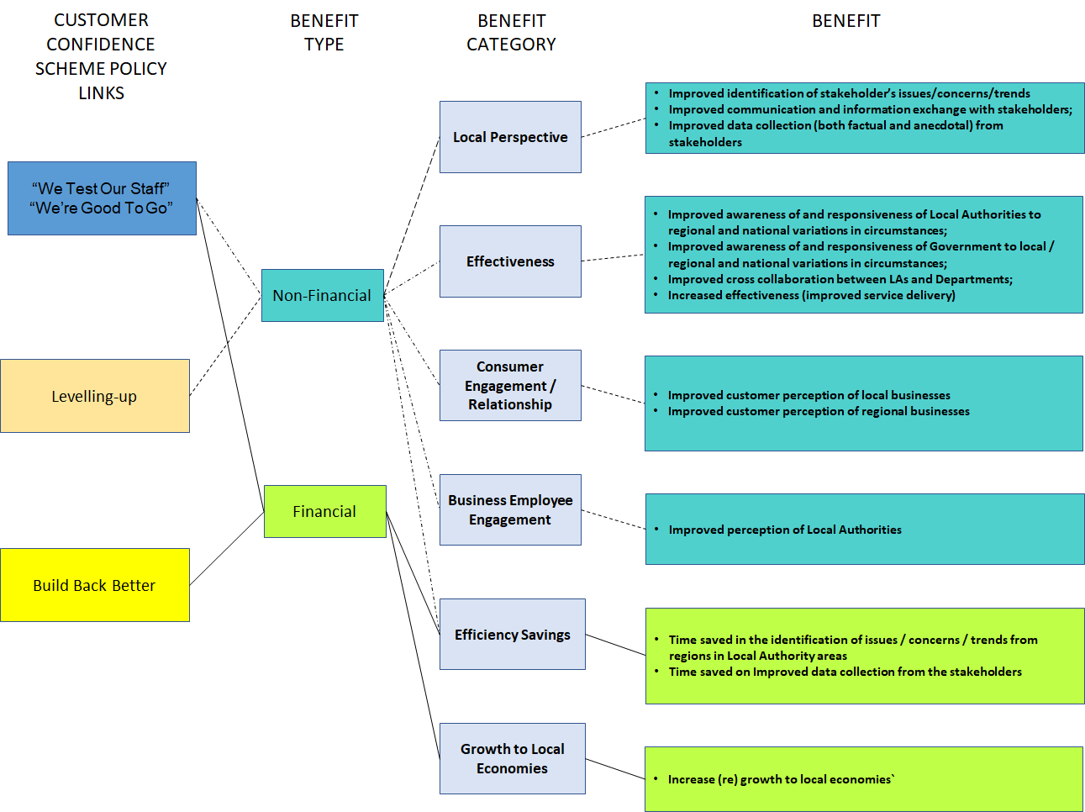
(Figure 1 – potential high-level benefits)

Non-financial benefits
Non-financial benefits are expected to include improvements in:
- Productivity – examples include the reduction of acuities such as retraining, staff satisfaction
- Quality and accessibility of information – reflecting improvements in the accessibility and accuracy of policy makers understanding of local perspectives
- Stakeholder engagement – examples include improvement in civil servants and community / region organisation and satisfaction in their collaborations leading to positive outcomes

Financial benefits
The financial benefits will include:
- Efficiency savings - which result mainly, but not exclusively, from time saved on activities related to data gathering, knowledge information, and time saved on completing tasks
- Productivity improvements - which represent the financial value (where this can be assessed) of increases in the range or number of tasks or services performed, where these do not result from efficiency savings
- Regional economics – which represents adding financial value to local economies
Financial savings may be classified as either cashable (i.e. the savings can be realised as reductions in operating costs) or non-cashable (i.e. the benefits will be re-invested in value-adding activities). Any financial savings derived from using the Consumer Confidence Toolkit will most improve the efficiency and effectiveness of service provision). For this reason, any efficiency savings should be treated as non-cashable benefits.
Measurement of benefits
The majority of the measures shown in Annex A can be measured by using information taken from derived from the results of the annual surveys that are already in place, and / or commission bespoke surveys, employee and public satisfaction surveys. Benefits should be monitored on a regular basis, at minimum on a quarterly basis. Staff surveys should be undertaken annually – these surveys can also be incorporated into existing audit / survey regimes already in place.
While Survey Monkey is a very cheap way to gain information from stakeholders, local authorities may also want to consider using a market research team to carry bespoke surveys. If using bespoke surveys as an option, the cost would be, at a minimum £1,500 - £2,250 for face-to-face market researchers (as of July 2021), but this could vary from location to location.
This cost would also increase if asking the market researchers to provide the analysis especially if there's lots of free text for them to analyse. You would also need to provide very clear support materials for the market researcher and interviewee e.g. a leaflet, a Q&A etc. The cheapest method would be to recruit colleagues and carry-out the work internally – again incorporating this piece of work with other relevant business / policy areas would be ideal.
Performance indicators
Local authorities may want to establish a range of performance indicators for the project itself, as well as the measures of benefit delivered by the policy initiative. These measures will each contribute towards effective management of performance at different at different points in time. Annex B presents a table that distinguishes between these types of performance measures.

Annex B: benefits of consumer confidence toolkit
# | Benefit | Measurement | Who / what to measure | Frequency | Measurement method / data source(s)
Local perspectives
B01 | Improved awareness of issues trends from the communities / local authorities / regions | By [date], a [%] increase in awareness of trends / challenges happening in communities/ local authorities / regions as a result of in comparison to 2021/22 baseline | Public / business perception | Yearly | LA bespoke public opinion survey  LA annual business survey  LGA surveys
B02 | Improved data collection (both factual and anecdotal) from the communities / local authorities / regions to inform on decision making | By [date], a [%] increase in stakeholders’ perception that there is improved data collection as a result of in comparison to 2021/22 baseline | Public / business perception | Yearly | LA bespoke public opinion survey  LA annual business survey  LGA surveys
B03 | Improved information exchange with local authority and regions | By [date], a [%] improved perception of local authorities and communities / regions / information exchange as a result of in comparison to 2021/22 baseline | Public / business perception | Yearly | LA bespoke public opinion survey  LA annual business survey  LGA surveys
Effectiveness
B04 | Improved awareness of the relevant local authority departments of their communities / regions circumstances leading to positive outcomes | By [date], a [%] improved awareness of local authorities, their communities, regions and nations’ circumstances leading to positive outcomes as a result of in comparison to 2021/22 baseline | Public / business perception | Yearly | LA bespoke public opinion survey  LA annual business survey  LGA surveys
B05 | Improved awareness of and responsiveness of government to local / regional variations in circumstances | By [date], a [%] improved positive perception by communities / regions of improved awareness of government to their circumstances as a result of in comparison to 2021/22 baseline | Public / business perception | Yearly | LA bespoke public opinion survey  LA annual business survey  LGA surveys
B06 | Improved cross collaboration between local authorities and departments | By [date], a [%] increase in positive perception of local authorities / communities that collaboration with government departments has improved as a result of in comparison to 2021/22 baseline | Public / business perception | Yearly | LA bespoke public opinion survey  LA annual business survey  LGA surveys
B07 | Increased effectiveness (improved organisational service delivery) | By [date], a [%] increase in positive perception by local authority workers they have improved their job effectiveness in comparison to 2021/22 baseline | Public / business perception | Yearly | LA bespoke public opinion survey  LA annual business survey  LGA surveys
Consumer engagement / relationship
B08 | Improved customer perception of local / regional businesses | By [date], a [%] increase in customer satisfaction of local businesses as a result of relocating in comparison to 2021/22 baseline | Public / business perception | Yearly | LA bespoke public opinion survey  LA annual business survey  LGA surveys
B10 | Improved customer perception of regional businesses | By [date], a [%] increase in customer satisfaction of regional businesses as a result of relocating in comparison to 2021/22 baseline | Public / business perception | Yearly | LA bespoke public opinion survey  LA annual business survey  LGA surveys
Region / nations engagement
B11 | Improved perception of business of their LA | By [date], a [%] increase in positive perception of communities / regions having positive of their local authority in comparison to 2021/22 baseline | Public / business perception | Yearly | LA bespoke public opinion survey  LA annual business survey  LGA surveys
Efficiency savings
B12 | Time saved in identifying issues trends from the communities / local authorities / regions | By [date], a [%] decrease in time to identify challenges happening in communities/ local authorities / regions as a result of in comparison to 2021/22 baseline | Business quantitative data | Yearly | LA bespoke public opinion survey  LA annual business survey  LGA surveys
B13 | Time saved in collection data (both factual and anecdotal) from the communities / local authorities / regions to inform on decision making | By [date], a [%] decrease in time to collect data collection as a result of comparison to 2021/22 baseline | Business quantitative data | Yearly | LA bespoke public opinion survey  LA annual business survey  LGA surveys
Region / nations engagement
B23 | Increase economic growth to local economies | By [date], a [%] growth to the local economies in comparison to 2021/22 baseline | i. New jobs arising in the business areas (the indirect effect)  ii. Increased consumer footfall | Quarterly | ONS – PAYE Real Time Data  Footfall figures – may be available via economic development or on PHE CRIP report for your area  High Streets Health indicator – data available from the Cabinet Office Places for Growth Team  Local data company

